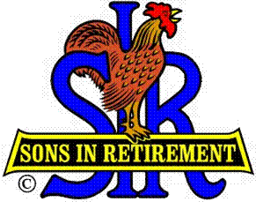
Las Trampas Branch 116
Luncheon Meeting Agenda
July 19, 2021, 11:30 AM
10:30 Check-in
Greeters at the door – Terry Grummitt, Alan Pope
Vaccination Check table – Kevin Donahue
Treasurer Table – Alan Fitzgerald, Al Satake
Name Tags Table – Mike Schneider
Raffle Table – Ben Bryce

11:25 Five Minute Call
11:30 Call to order; Opening Remarks – Big SIR
Pledge of Allegiance – Roger Craig
Chaplain – Terry Sherman
Sunshine Report – Matt Arena

11:40 Story Teller – Fred Schafer
11:45 Introduce New Members [2021] & guests
Recognize all worked hard to keep branch viable during last 17 months

11:45 Salad Served
12:00 Lunch
12:25 Activity Committee Announcements
12:35 Introduce Speaker – Little SIR
13:10 Speaker Thank You – Little SIR
13:12 Raffle Drawing – Ben Bryce
Birthday Drawing – Little SIR
13:20 Sing Happy Birthday – Music – Dave Williams, Paul King
Sing God Bless America - Dave Williams, Paul King

13:25 Closing Remarks – Big SIR
13:30 Adjourn; Next Meeting, August 16, Election of Officers and Directors
************************************************
Red letters means: confirmed

New Members – 2021:
Dave Havlik: his sponsor - Fred Schafer.
Dick Frankel: his sponsor - Paul Freitas
Bruce Bressler: his sponsor - Don Schroeder

Guests for July 19, 2021:
Terry Sherman's guest is Bill Foulds
Mike Yale's guest is Gary Diefenbacher
Robert Vetro’s guest is Paul Vetro

